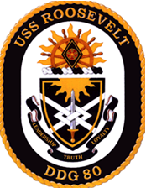
USS ROOSEVELT (DDG 80)
COAT OF ARMS

SHIELD: Blue and gold represent the Navy. The fret represents President Roosevelt's leadership skills in bringing stability and strength to American society during the crisis of the Depression and the threat of fascist aggression. His call to Americans for preparedness and confidence and his resolve during World War II are denoted by the sword, which also indicates DDG 80's readiness to deploy her modern weaponry in defense of the country. The demi-sun signifies truth and the aspirations for a better world, which President Roosevelt encouraged Americans to share with him. The orie signifies the unity he brought to the country and the all-encompassing areas of responsibility of his office, which he administered so ably. White represents integrity and loyalty, and gold denotes excellence.

CREST: The demi-burst signifies the splendid achievement of Franklin D. Roosevelt's Presidency, in bringing the United States out of domestic crisis and through worldwide conflict. The ship's wheel recalls his appointment in 1913 as Assistant Secretary of the Navy. It also denotes his success in guiding America through the difficult years of his Presidential terms. The lozenge, traditionally a feminine heraldic symbol, is a reference to his wife, Eleanor Roosevelt, who assisted him politically and became a force in her own right. The sides of the lozenge represent his four elections to the presidency. The rose, the state flower of New York, recalls his governorship of that state and is a canting reference to his family name. Scarlet denotes courage and sacrifice and gold indicates excellence.

SEAL: The coat of arms in full color, as in the blazon, upon a white oval, within a dark blue border, edged with gold rope on the outside and inscribed "USS ROOSEVELT" at the top and "DDG 80" at the bottom all in gold.

Homeport: Rota, Spain
Assigned to Naval Surface Squadron Sixty
Forward Deployed Forces - Europe
Fleet Forces Command

Dimensions
Overall Length ……………………………….. 509.5 ft
Beam ……………………………………………. 66 ft
Displacement Projected Full Load ………….. 9200 tons
Mean Draft at Projected Full Load ……………….. ...33 ft

Sensors/Armament
AN/SPY-1D(V) air search, AN/SPQ-9B multi-purpose search, AN/SPS-73(V)12 surface search, AN/SQQ-89(V) 15 SONAR Suite, AN/SQS-53C SONAR
1 32 Cell and 1 64 cell Mk 41 Vertical Launch System
Capacity for 96 RIM-66 SM-2, BGM-109 Tomahawk or
RUM-139 VLA Rockets
1 Fwd Mounted Mk 45 5”/54 cal Gun System, (20 rpm)
1 Fwd 20mm CIWS (4500/3000 rpm)
1 Aft SeaRAM
2 Mk 38 Mod 2 25 mm Guns (200 rpm)
4 M2 50 Cal. Crew Served Machineguns
Accomodations
36 Officers and 282 Enlisted Sailors

Main and Auxiliary Machinery Systems
Gas Turbine/Electric Drive Main Propulsion Plant:
4 General Electric- LM 2500 Gas Turbines
2 Shafts with CRP (Controllable Reversible Pitch) Propellers
Electric Power Plant .......... 3 x 3000 KW Gas Turbine
3 Allison 501K34 Generators

All-Electric Auxiliaries:
Air Conditioning Plants ……………………... 4 x 200 ton
Reverse Osmosis Plants ………………….. 2 x 12,000 gpd
Fire Pumps ………………………………. 6 x 1,000 gpm

Aircraft Embarked
1 MH-60R Sea Hawk Helicopter – HSM 48.7 Venom 501

EMERGENCY PHONE NUMBERS
BRIDGE………………..………….…. 23009/23003
CIC……………………………….…………….22700
CCS……………………………………….……26001
CSMC…………………………………………..25011
MEDICAL……………………………………..28001

WELCOME ABOARD
USS ROOSEVELT (DDG 80)
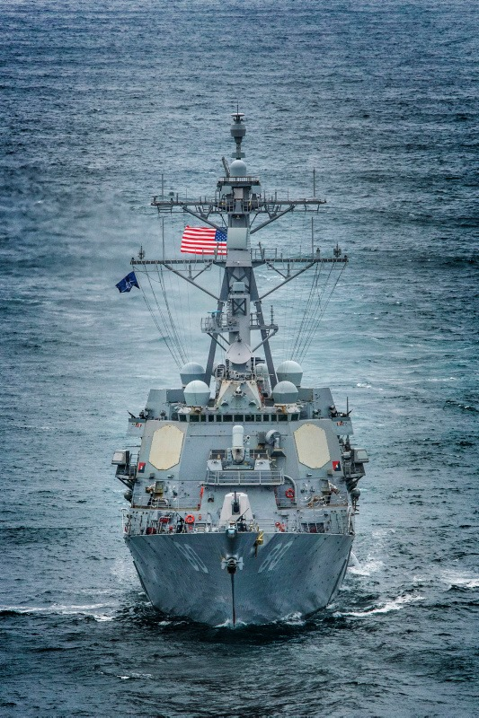

“In the face of great perils never before encountered, our strong purpose is to protect and to perpetuate the integrity of democracy. For this we muster the spirit of America, and the faith of America. We do not retreat. We are not content to stand still. As Americans, we go forward, in the service of our country, by the will of God.”

Franklin Delano Roosevelt
32nd President of the United States

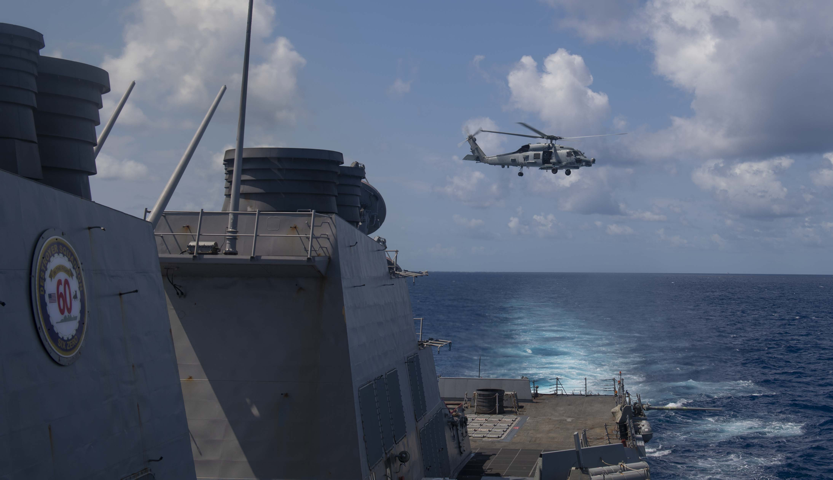

USS ROOSEVELT (DDG 80) HISTORY
Contract Awarded ………………….…......... January 6, 1995
Keel Laid …………………....................... December 15, 1997
Launch …………………….......................... January 10, 1999
Christening …………………....................... January 23, 1999
Commissioned………………..............…...October 14, 2000

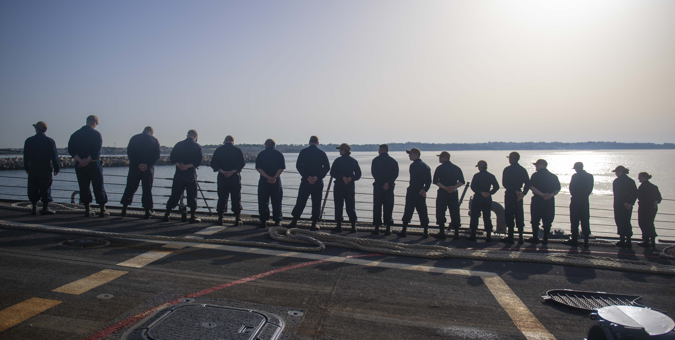

The Arleigh Burke-class guided-missile destroyer USS Roosevelt (DDG 80) recently joined Sixth Fleet as a Forward Deployed Naval Forces-Europe (FDNF-E) ship in Rota, Spain. Roosevelt is one of the few destroyers in the Surface Navy with the Advanced Capability Build (ACB-12/BMD 5.0) which provides software upgrades for combat systems modernization. The ship has the following integrated weapons and sensors: Cooperative Engagement Capability; ESSM; Mk 15 Close-In Weapon System Block 1B; Surface Electronic Warfare Improvement Program (SEWIP); and Nulka decoys. Roosevelt is also the only destroyer with the SPQ-9B radar onboard and the first Flight IIA FDNF-E in Sixth Fleet, providing the ability to deploy with two embarked Lamps MK III MH-60B Sea Hawk Helicopters.

FRANKLIN AND ELEANOR ROOSEVELT

On October 22, 1996, the Secretary of the Navy, John H. Dalton, named the 30th ship of the Arleigh Burke class ROOSEVELT. The USS ROOSEVELT (DDG-80) is the first ship so named to honor both Franklin Delano Roosevelt, the 32nd President of the United States and the First Lady, Eleanor Roosevelt. Mr. Dalton made the announcement at an event marking Roosevelt History Month at the U.S. Navy Memorial in Washington. "Naval Commanders found an ardent ally and vocal supporter in FDR," Mr. Dalton said. "As Commander-in-Chief during the most trying period of our nation’s history, he maintained a clear sense of the mission at hand."

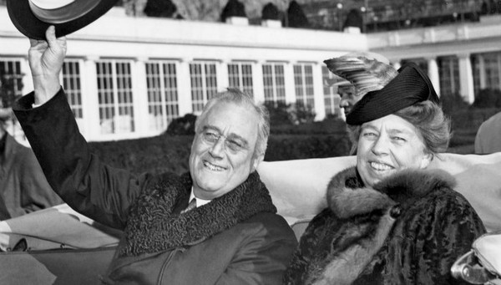

Upon FDR’s election as President in 1932, Eleanor became a powerful voice on issues from youth employment to civil rights. Eleanor traveled around the world visiting sick and injured servicemen, fostering good will among the Allies, and boosting the morale of U.S. military personnel overseas.

Franklin D. Roosevelt entered public service as a State Senator in his native New York in 1910. President Woodrow Wilson appointed him Assistant Secretary of the Navy, an assignment he held for seven years. Elected to the first of four terms as President in 1932-during the depths of the Great Depression, Roosevelt helped the American people regain faith in themselves. He brought hope as he promised prompt, vigorous action, asserting in his first Inaugural Address, "The only thing we have to fear is fear itself." His "New Deal" was a wide ranging economic and social program that greatly expanded the role of the federal government. In 1940, while attempting to keep the United States out of the brewing war in Europe, after France fell and England came under attack, Roosevelt sent all possible aid short of actual U.S. Military involvement. Then immediately following the Japanese attack on Pearl Harbor, Roosevelt directed the organization of the nation's manpower and resources for global war.

Sir Winston Churchill called FDR, "The greatest American friend we have ever known... and the greatest champion of freedom who has ever brought help and comfort from the new world to the old."

ROOSEVELT LEADERSHIP
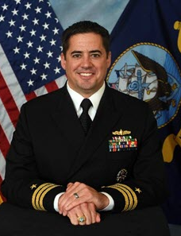
CDR Ryan Kendall
Commanding Officer

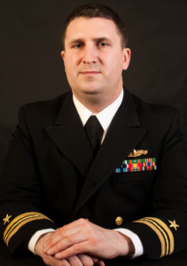
CDR John Mastriani
Executive Officer
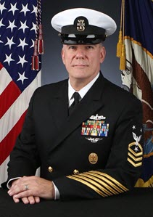

CMDCM (SW/AW/IW) James Kuroski
Command Master Chief

